**Best Pasta Places throughout the US**

IBM Professional Certificate Capstone Report

By: Kristianne Baugh

1. **INTRODUCTION**
   1. **Background:**

When visiting new cities, tourists generally want to try the best places in that city. Whether it be popular hangouts, venues, tours, or restaurants. For this analysis, the focus was primarily the popularity of certain Italian restaurants throughout the US. According to the Daily Meal web blog, there are not shortages of Italian restaurants to choose from throughout the US and within the major cities. They also mention have a list of the best Italian restaurants throughout the US.

* 1. **Problem Description:**

While the Daily Meal has a great list of places to visit, if a tourist is craving Italian food, my approach to this problem will be to use Foursquare API to collect the data on Italian restaurants within New York, Michigan, Houston, Seattle, and Massachusetts. I will then compare them in order to determine the best places to eat Italian food. My target audience will consist of mainly tourists, travelers, bloggers, and vloggers who are looking for the next best pasta.

1. **DATA SELECTION**
   1. **Data Sources:**

Foursquare API was used to collect data about the locations of pasta restaurants in the following US cities: New York, Michigan, Houston, Seattle, and Massachusetts. I am hoping that this data will provide enough information to determine the best restaurant to visit according to the above-mentioned success criteria.

I will use Foursquare to gather the top Italian restaurants within those cities, and then compare their popularity in order to determine the best restaurants in those locations. I will then compare the top restaurants with each other to determine which one would be the absolute best Italian restaurant to visit.

1. **METHODOLOGY**
   1. **Scenarios and Data Cleaning**

Starting with New York, at the Plaza Hotel, I entered “Italian” into my search query, made the radius 1000, and came up with the following results:

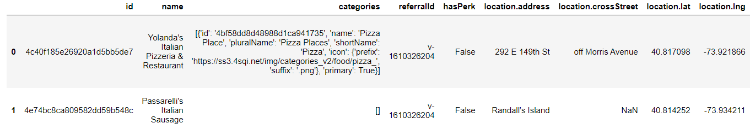

While it seems that there should be significantly more options to choose from, I continued with my analysis. I cleaned up the data so that the table flowed more smoothly:

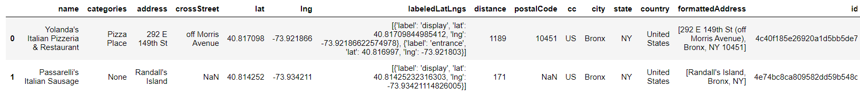

I presided to get a visualize of how close the restaurants were from the Plaza, keeping in mind that timing and distance would be a contributing factor.

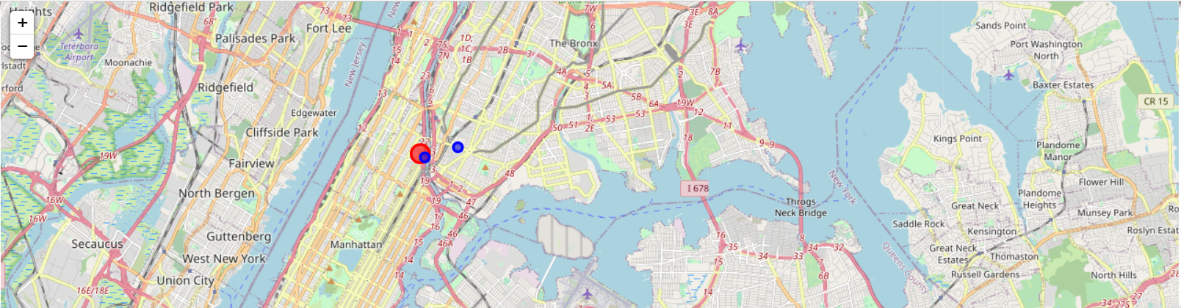

I did the same for Detroit, MI, Houston, TX, Seattle, WA, and Boston, MA, getting a different number of restaurants each time.

1. **ANALYSIS AND CONCLUSION**

Now that I had compiled a list of each of the cities best Italian restaurants, according to the Foursqaure API, I wanted to compare each one and see how they ranked. Again, I started with New York and compared the two restaurants that are above. Unfortunately, both of their ranks were 7.9, which does not really help me figure out which place to try. In the New York scenario, the logical conclusion, based on the information obtained, I would travel to the one closest to where I was currently.

I continued this process through each of the cities and their restaurants and found a flaw in my procedure. Each restaurant came back with the rank of 7.9, which, overall, does not assist in determining the best restaurants to try throughout the US. The upside to this information is that it does help determine which locations within the cities that would have a decent restaurant.